- \Operation\Carton\Carton erection system (page 1 of 2)
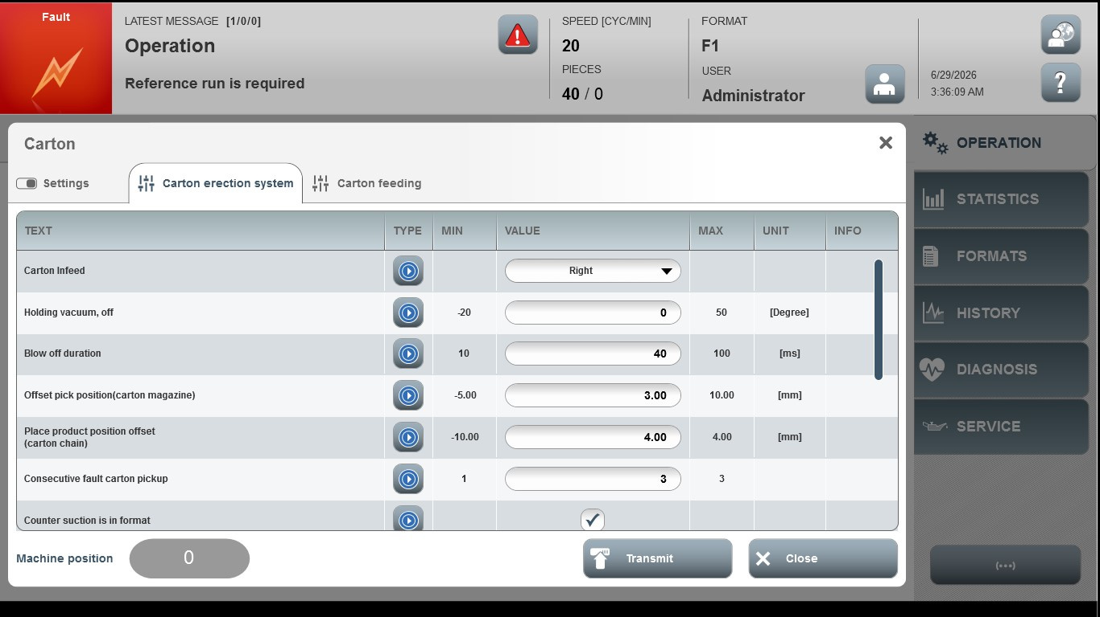
Acceptance criterion | Limits | Pass / Fail: Dev-No. | Date | Initials
Screen matches screenshot | N / A
Holding vacuum, off | -20 … 50
Blow off duration | 10 … 100
Offset pick position  (carton magazine) | -5.00 … 10.00
Place product position offset  (carton chain) | -10.00 … 4.00
Consecutive fault carton pickup | 1 … 3

- \Operation\Carton\Carton erection system (page 2 of 2)
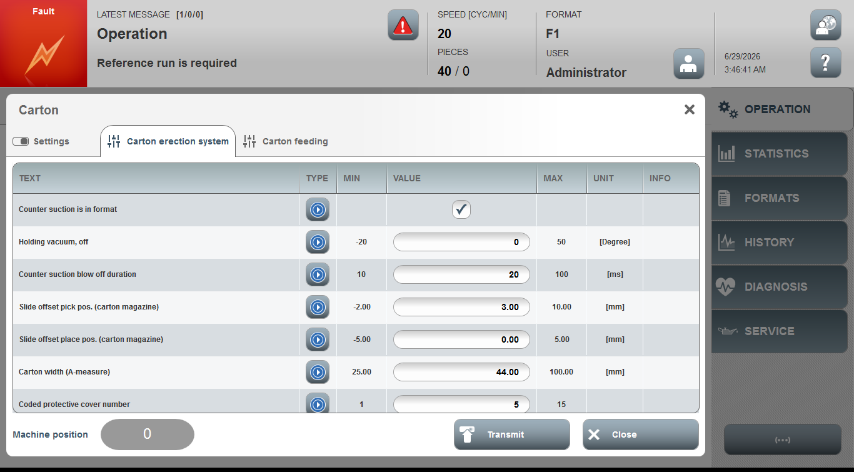
Acceptance criterion | Limits | Pass / Fail: Dev-No. | Date | Initials
Screen matches screenshot | N / A
Holding vacuum, off | -20 … 50
Counter suction blow off duration | 10 … 100
Slide offset pick pos. (carton magazine) | -2.00…10.00
Slide offset place pos. (carton magazine) | -5.00…5.00
Carton width (A measure) | 25.00 … 100.00
Coded protective cover

